# Ranking Athletes by Medals Earned

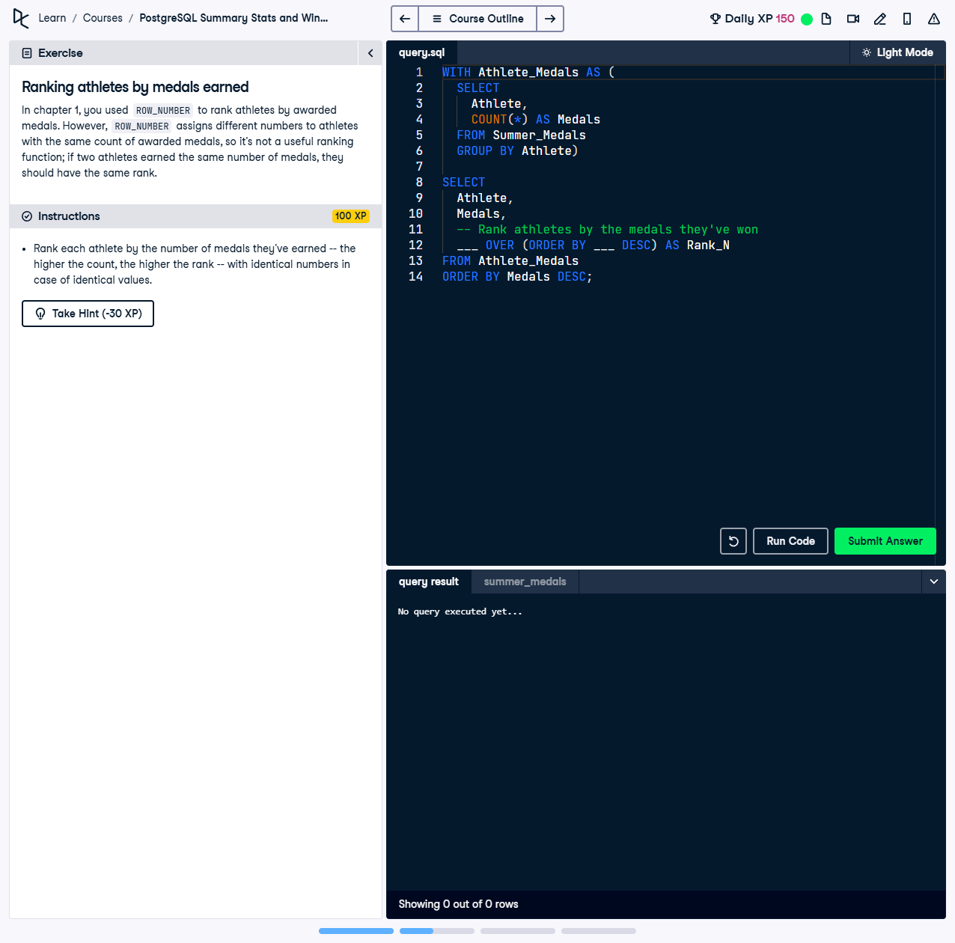

In chapter 1, you used `ROW_NUMBER()` to rank athletes by awarded medals. However, `ROW_NUMBER()` assigns different numbers to athletes with the same count of awarded medals, so it’s not a useful ranking function. If two athletes earned the same number of medals, they should have the same rank.

This exercise involves using a Common Table Expression (CTE) and the `RANK()` function to rank athletes based on the total number of medals they have won. The `RANK()` function ensures that athletes with the same medal count are assigned the same rank.

## Correct Answer

WITH Athlete_Medals AS (  
 SELECT  
 Athlete,  
 COUNT(*) AS Medals  
 FROM Summer_Medals  
 GROUP BY Athlete  
)  
SELECT  
 Athlete,  
 Medals,  
 RANK() OVER (ORDER BY Medals DESC) AS Rank_N  
FROM Athlete_Medals  
ORDER BY Medals DESC;

Explanation of the query:

1. `WITH Athlete_Medals AS (...)`: This CTE calculates the total medals won by each athlete, using `COUNT(*)` to count their rows in the dataset and `GROUP BY` to aggregate the results.

2. `RANK() OVER (ORDER BY Medals DESC) AS Rank_N`: The `RANK()` function assigns ranks based on the medal count in descending order, ensuring athletes with the same count receive the same rank.

3. `ORDER BY Medals DESC`: The final output is sorted by the number of medals in descending order, listing the highest achievers first.